Statistics, Facts and Figures of world Hunger in 2022/2023

Food is a basic need for humans but in the world sometimes people haven’t anything to eat because of the problem of global farming. Global farming is the major problem in society. This happens because of climate changes like wind issues and natural disasters and food waste of the society in developed countries. So, in below there are some statics, facts and figures of the hunger of the people.

The facts and figures that many people are starving today.

In worldwide around 821 million people are starving with hunger it is 11% in world’s population. There are about 2 billion people that suffer from malnutrition and there are one in 9 people that don’t have enough food to eat . Also, if we get 12 males there is a malnourished one boy or a man and if we get 5 females there is a one girl or a woman in worldwide.
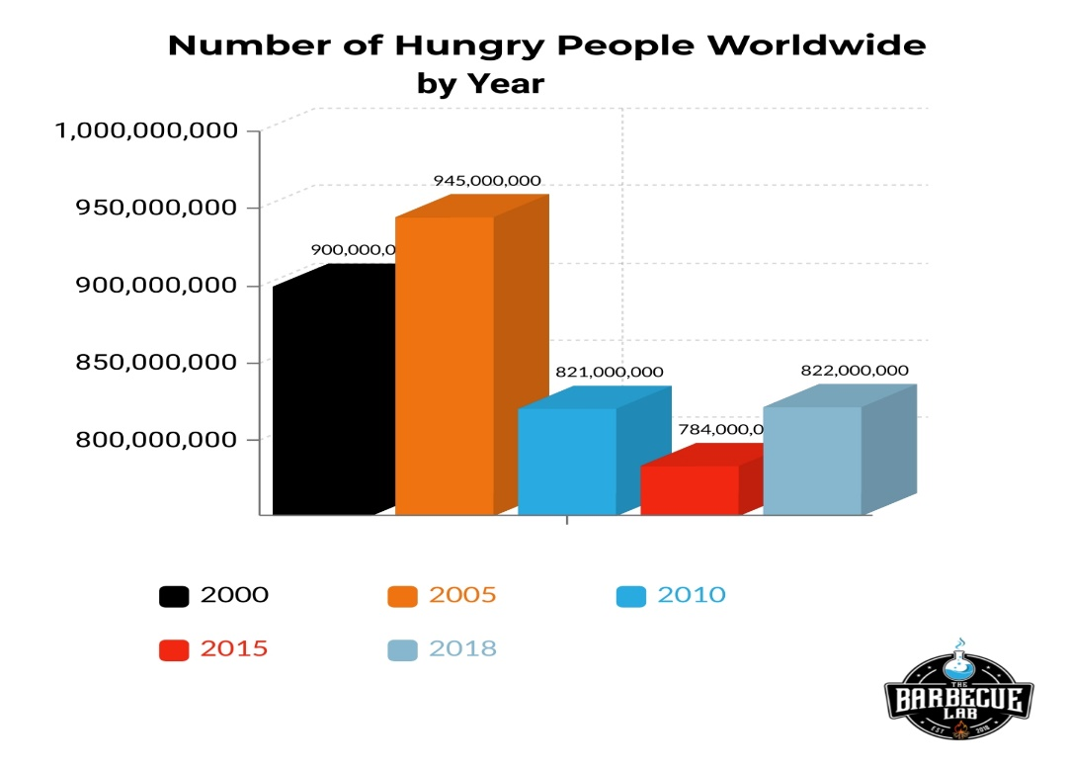
Figure 1 : Number of Hungry People worldwide by y
The facts and figures that many children are suffering or dying.
because of Hunger

According to UNICEF , they show that there are15% newborns are
born in underweight and because of malnutrition 161 million children.
that are age 5 are under developed. These kind of children about three
quarters are live in sub -Saharan Africa and South Asia.
In each year overall 3.1 million under the age 5 children are died
because of hunger and every 10 seconds a child dies from hunger.

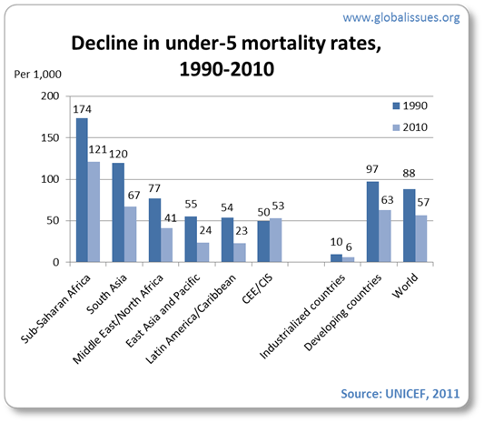
Figure 2 : Chart of worldwide Decline in under -5mortality rates 1990-2010

Places that are many people are suffering from Hunger.

In developed countries there are also about 16 million people who are
suffering from hunger. In 2019 ranked countries that were suffering
from hunger and malnutrition are (out of 100points) ,

- The Central African Republic – 53.6
- Yemen – 45.9
- Chad – 44.2
- Madagascar – 41.5

There are eight countries where 2 to 3 people are suffering from hunger. Those countries are known as ,

- Afghanistan
- Ethiopia
- Democratic Republic of Congo
- Yemen
- Nigeria
- Sudan
- South Sudan
- Syria

The countries whose hunger rates were largest increased are
Swaziland(59%),Iraq(48%),Comoros (28%) and Burundi(11%).
In 2019 the highest score of world hunger countries is the
South Asia and Sub-Saharan Africa . The scores are 29.3 and
28.4.

Statistics and Data of the Food Wasting

In Worldwide every year overall 1.3 billion tons of food are wasted.
Germens they throw 84% of food because of expired and other.
reasons are 25% of buying too much food ,19% too large of product.
packaging and 16% the product taste is not good. In Germany they
throw 356 million kilograms per year. In Rich countries people are
wasting 222million tons of food within a year. If we looked Sub-
Sharan Africa in there the total food production is 230 million tons.

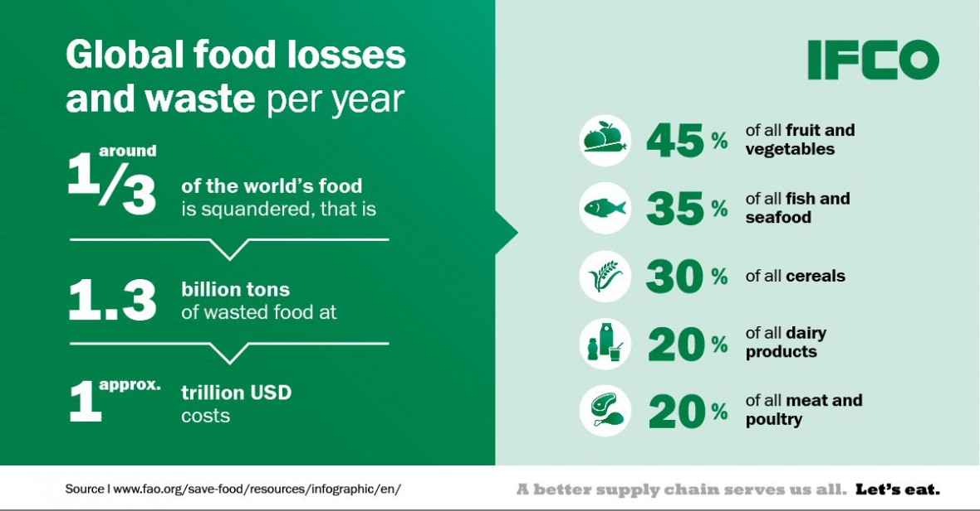
Figure 3 : Global Food waste and losses per year

The annual emissions of greenhouse gases (GHG) equivalent to 3.3
billion tons of CO2 from food waste are calculated. The entire water
required to grow food each year that is lost or squandered (250km3) is
equal to the Volga River's yearly flow in Russia or is three times the
size of Lake Geneva.

References

- Anon., 2023. The Barbecue Lab. [Online]
Available at: https://thebarbecuelab.com/world-hunger-statistics/
[Accessed July 2023].

- Anon., n.d. Food and Agriculture Organization of the United Nations. [Online]
Available at: https://www.fao.org/news/story/en/item/196402/icode/

- Schulz, C., 2020. CareElite. [Online]
Available at: https://www.careelite.de/en/world-hunger-statistics-facts/
[Accessed 7 january 2020].

